NAME ______________________________________________________________ SECTION: ______________

PROJECT: SURRENDER THE SELF – BRIDGE THE DIVIDE DATE:__________________

ARTISTIC SKILLS /70 POINTS
Reflect on your finished work to see if you understood and demonstrated the evaluation standards by rating yourself.

Not at all Some Always EVALUATION STANDARDS

0 1 2 3 4 5 Created an effective symmetrical mask design on paper so your mask
had correct proportions.
0 1 2 3 4 5 Built nose, eyes, and mouth or something creative in those areas.

0 1 2 3 4 5 Built forehead & cheeks to create an eye socket that protects the eye.

0 1 2 3 4 5 Formed a jaw and chin – it’s not just flat in that area.

0 1 2 3 4 5 Added details that enhanced the mask (nostrils to nose, eyelids to
eyes, created an expression with lips)
0 1 2 3 4 5 ALWAYS used the 4 S’s when attaching clay.

0 1 2 3 4 5 Carved out the back so the mask is an even ½” thick.

0 1 2 3 4 5 Carved initials and section neatly into the back.

0 1 2 3 4 5 Your mask has a lot of dimension – it pops out at me & it is not flat.

0 1 2 3 4 5 Smoothed the edges and surface of the clay.

0 1 2 3 4 5 Cleaned up after yourself and helped classmates (tools in the right
place, washed tables, stored work correctly, followed directions)
0 1 2 3 4 5 Used tools and materials properly (did not throw or waste clay, used
tools as they were supposed to be used, took care of materials)
0 1 2 3 4 5 Mixed a color to paint entire mask with (there is NO clay showing)

0 1 2 3 4 5 Painted or added other materials using creativity (original and unique)

ARTISTIC KNOWLEDGE /14 POINTS
Write your answer in a short phrase.

/6 List 3 uses for masks.

/4 Masks have been used everywhere, in every culture, for as long as humans have existed. Different cultures have different forms, uses, and looks. The oldest existing mask is 5000 year old. It is a Sumerian mask, called “Lady of Uruk” from 3100BCE. If you wanted to go see “Lady of Uruk” what country would you have to travel to?
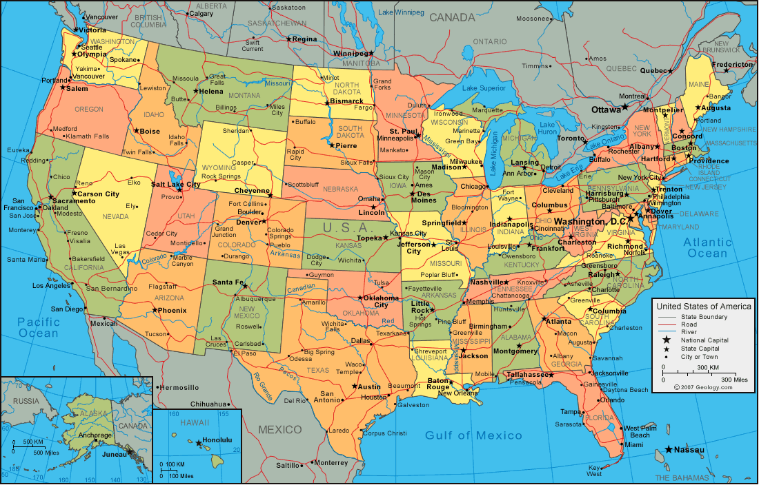

/4 Your partners are from the state of Wisconsin.
Circle Wisconsin on the map.

ARTIST STATEMENT /75 POINTS
In your writing for step 3 about your inspiration and yourself, did you follow the directions and give details?

Part 1: Your inspiration
For each photograph, you should have one paragraph that answers the following questions.

/10 What was the photograph of? Describe it in detail.
/10 What caught your attention? What inspired you? Why?
/10 How did you include that, or represent that, on your clay mask?
/10 Proper punctuation and grammar. You used complete sentences.

Part 2: About You
Your partner gave you 27 personal photographs. If a picture says 1,000 words, they gave you 27,000 words, or about 54 typed pages of writing. Photographs are very personal and they trusted you . . . they let you look at their life and showed you honestly who they are. You wrote your partner back giving of yourself.

/5 You wrote in letter format. It started: “Dear ____________,”
/10 Proper punctuation and grammar. You used complete sentences.
/20 You shared about yourself literally, symbolically, physically, and representationally. You trusted your partner and gave back to them what they had given to you in photographs.

This is not graded, but I want you to reflect on yourself . . .
Rate yourself in effort in this project: 0 1 2 3 4 5
Rate yourself in responsibility in this project: 0 1 2 3 4 5

Is there anything else you want to share with me?
______________________________________________________________________________
______________________________________________________________________________
______________________________________________________________________________
_______________________________________________________________________________________

TOTAL POINTS EARNED

Artistic Skills ________/70

Artistic Knowledge ________/14

Artist Statement ________/75

